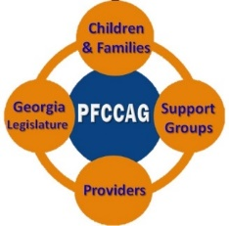

Macon-Bibb County Zoning Requirements for Family Child Care (FCC)

Narrative Explanation for FCC Applicants and Applicant Support Organizations

© Professional Family Child Care Alliance of Georgia
For Family Child Care Marathon Project
Co-authors Joe Perreault and Logan Creel
For permission to use, e-mail joeperreault@comcast.net

Note: This paper is intended to increase the supply of high quality affordable family child care in Georgia. The paper assists individuals interested in providing family child care, (aka Family Child Care Learning Homes), comply with zoning law in their county/city. Whenever possible, the authors quote from the law and include the specific section(s) which apply. Individuals using this document are requested to notify the authors (see e-mail above) if there are errors or misstatement in the paper.

Note: This paper does not render legal or other professional advice concerning the zoning process in general or in a specific community. If you require this type of assistance, please consult a professional to represent you.

This paper is best understood and used in conjunction with a parallel document: Macon-Bibb County Zoning Requirements for Family Child Care (FCC): Applicant Zoning Analysis for FCC Applicants and Applicant Support Organizations.

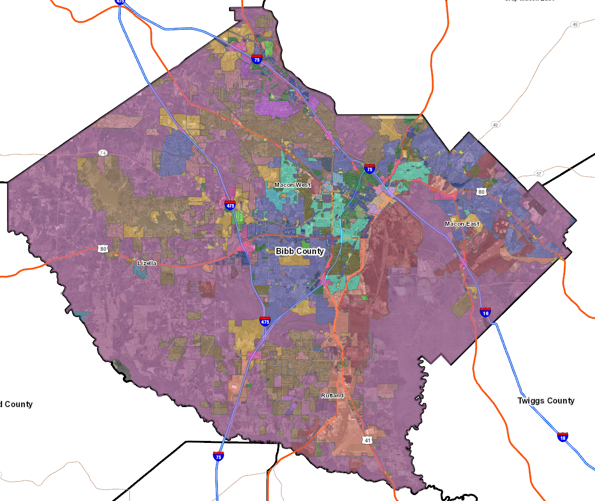

IF YOU WANT TO BE A FAMILY CHILD CARE PROVIDER CARING FOR YOUNG CHILDREN WHILE THEIR PARENTS WORK, WHY DOES ZONING MATTER?
In each county and often large cities, zoning laws are put in place to maintain a certain harmony to the community by limiting the uses of the land. For instance, you would not want there to be a massive coal mining operation in the middle of a large suburban neighborhood. These laws divide the county into “districts” or “zones” and determine in each district, what and where certain buildings may be built, what occupations may use those buildings, how much space they can take up, how far apart they have to be, how far from the road they need to be and so on.
According to the Child Care Law Center, “Within each district, certain activities are allowed as a matter of right, meaning that property owners do not need to get permission from the local government to use their property in a particular ‘pre-approved’ manner”* In a few Georgia counties/cities, (e.g. Clarkston, Roswell) Family Child Care (FCC) is permitted as a matter of right, although, even in these cities, a few conditions apply.
In most counties/cities, FCC is a use that must be explicitly allowed within a district. The property owner must apply for permission to use the property in the specified manner and agree to meet any “conditions” (aka conditional use requirements), stated in the law for that particular use. However, because each city/county establishes their own zoning law, there is wide variation in how FCC is treated. The differences may show up in how FCC is defined, in which districts it is permitted or not permitted, what conditions an applicant must comply with, and what is the cost, time , and process involved in obtaining permission to use your home as a FCC business.
This paper aims to answer the following questions for Macon-Bibb County based on the Macon-Bibb County Land Development Resolution:
- How is family child care defined within Macon-Bibb County?
- What sort of conditions are put in place for family child care?
- How would I locate what district I live in to determine if I qualify?
- Within what district(s) is family child care allowed?
- If I do qualify, what do I need to do?
- Does it cost anything?
Note: While the paper speaks directly to FCC applicants and applicant support organizations in Macon-Bibb County, we hope it serves as an example to applicants in other Georgia cities-counties of how to research the zoning law in their community
HOW IS FAMILY CHILD CARE DEFINED WITHIN MACON-BIBB COUNTY?
Within Macon-Bibb County, Georgia, family child care as a zone use is defined as a day care home under Section 1.02 [32] of the Macon-Bibb County Land Development Resolution. It is not a day care center, playschool, home occupation, office in the home, or group personal care home.
WHAT SORT OF CONDITIONS ARE PUT IN PLACE FOR FAMILY CHILD CARE?
There is a specific section of the law, section 23.30 Supplementary Regulations Governing Certain Uses: Day Care Home which lists 11 conditions for day care homes. The key conditions are identified below. Potential applications should be especially aware of the following conditions:
- Day care homes shall only be allowed within single family detached dwellings. (This is the greatest restriction to day care homes in this document. See Section 1.02 [37] – Section 1.02 [41] for dwelling definitions)

- Hours of operation shall be limited to Monday thru Friday from 6:00 a.m. to 6:00 p.m.

- No more than six (6) children under the age of seventeen (17) may be cared for at any one (1) time, including those that are permanent residents of the dwelling where the day care home is located.

- Outdoor play area shall be fenced or otherwise enclosed and shall not include driveways, parking areas, or land unsuited for children’s play area. Outdoor play area shall not be allowed in the front or side yards of the dwelling. (see Section 1.02 [110] – 1.02 [113] for yard definitions)

- The operator of a day care home shall be the owner of the property or as a renter have written permission from the property owner.

HOW WOULD I LOCATE WHAT DISTRICT I LIVE IN TO DETERMINE IF I QUALIFY?
From the Macon-Bibb County Planning & Zoning website navigate to the Public Bibb County, GA Map through the following links.
https://mbpz.org/
Under Research: Click “Do Your Homework Here”
Click the Maps & GIS Data dropdown
Click “Macon-Bibb Tax Records/QPublic”
If viewing online, simply click the following link: https://qpublic.schneidercorp.com/Application.aspx?AppID=702&LayerID=11410&PageTypeID=1
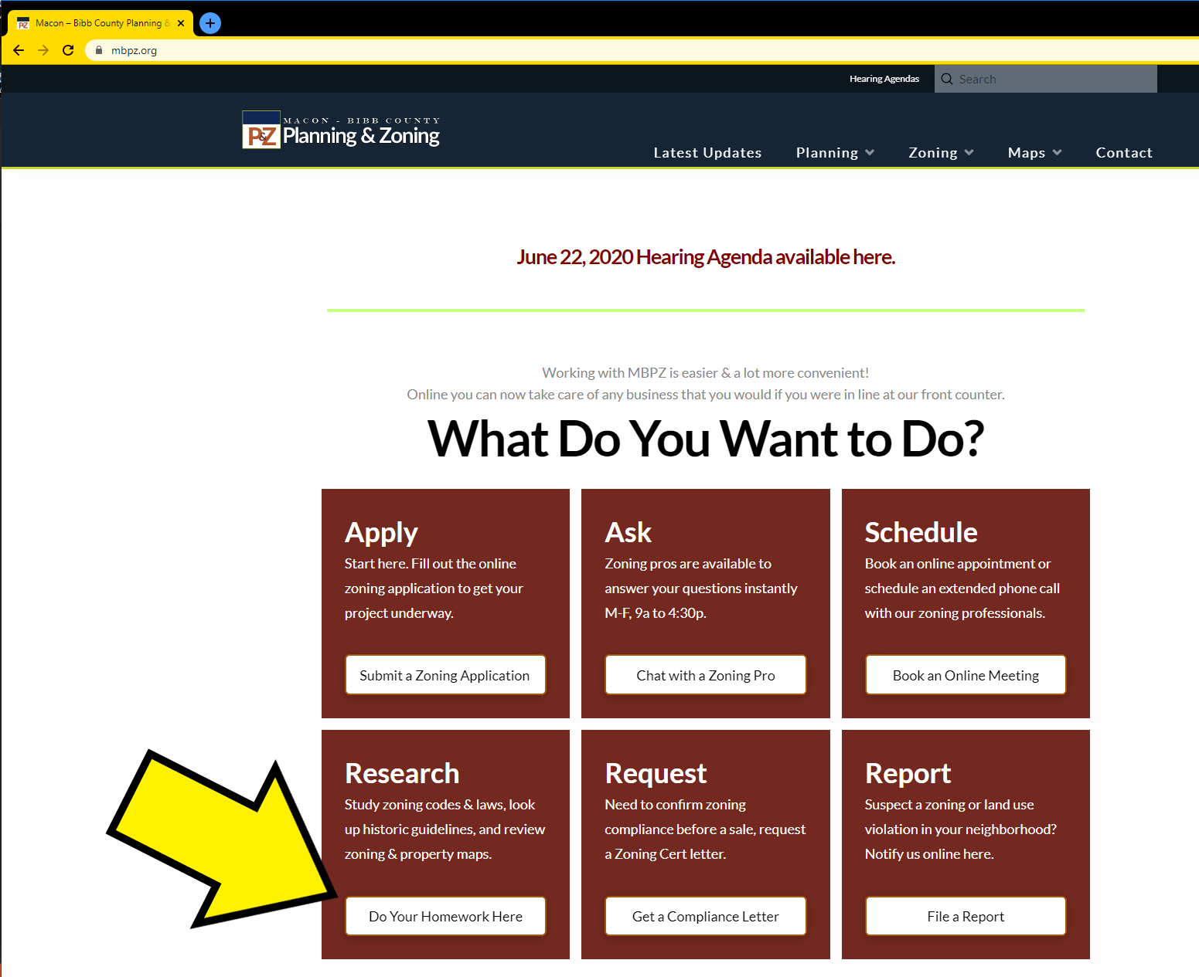
Step 1 Planning and Zoning Home Page
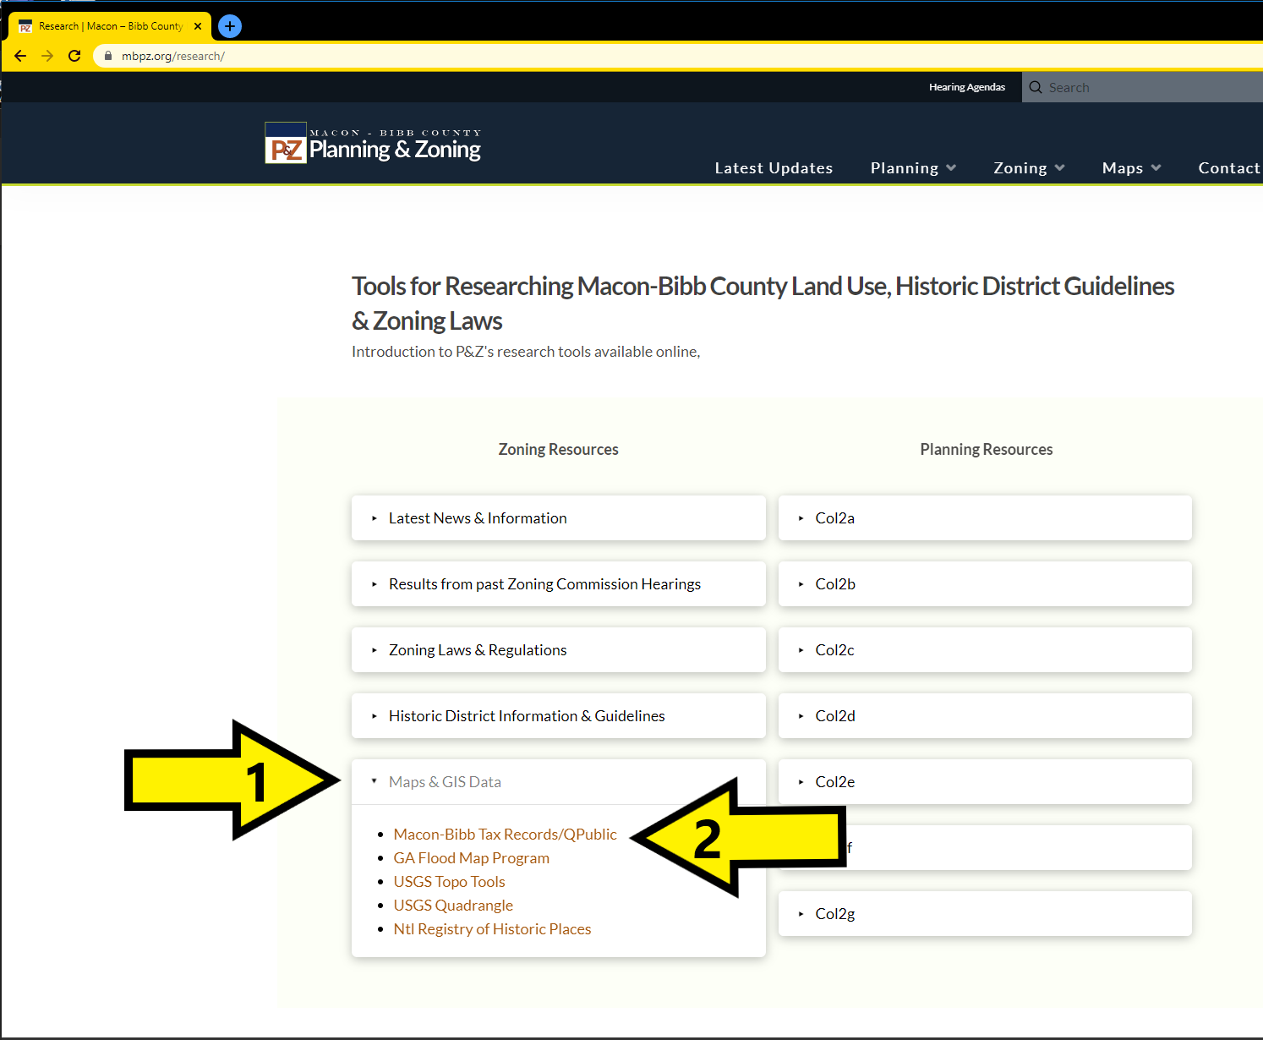
Step 2 Click 'Maps and GIS Data' and then the first link

Once you are in this site, you can search for the property records of your home by using the Search option from the blue banner. It is easiest to search by your address, but you will also have the option to search by Owner Name, Parcel Number, Real Key / Account Number, Legal Information, or Reprop Key. If found successfully, your property information will be shown and under Summary > Zoning the abbreviation for your district will be listed. This will be alpha-numerical, like R-1A or C-1.
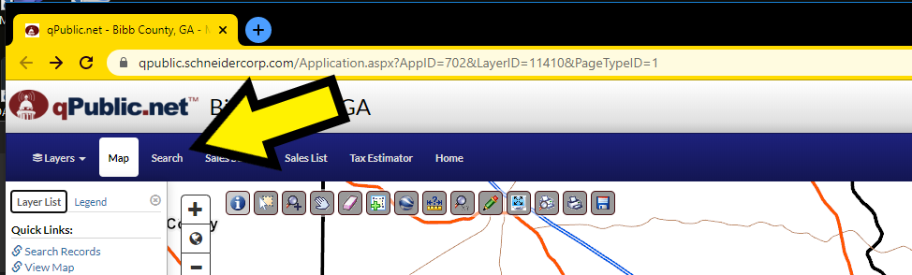
Step 3 To Search your home, first click 'Search' from the banner
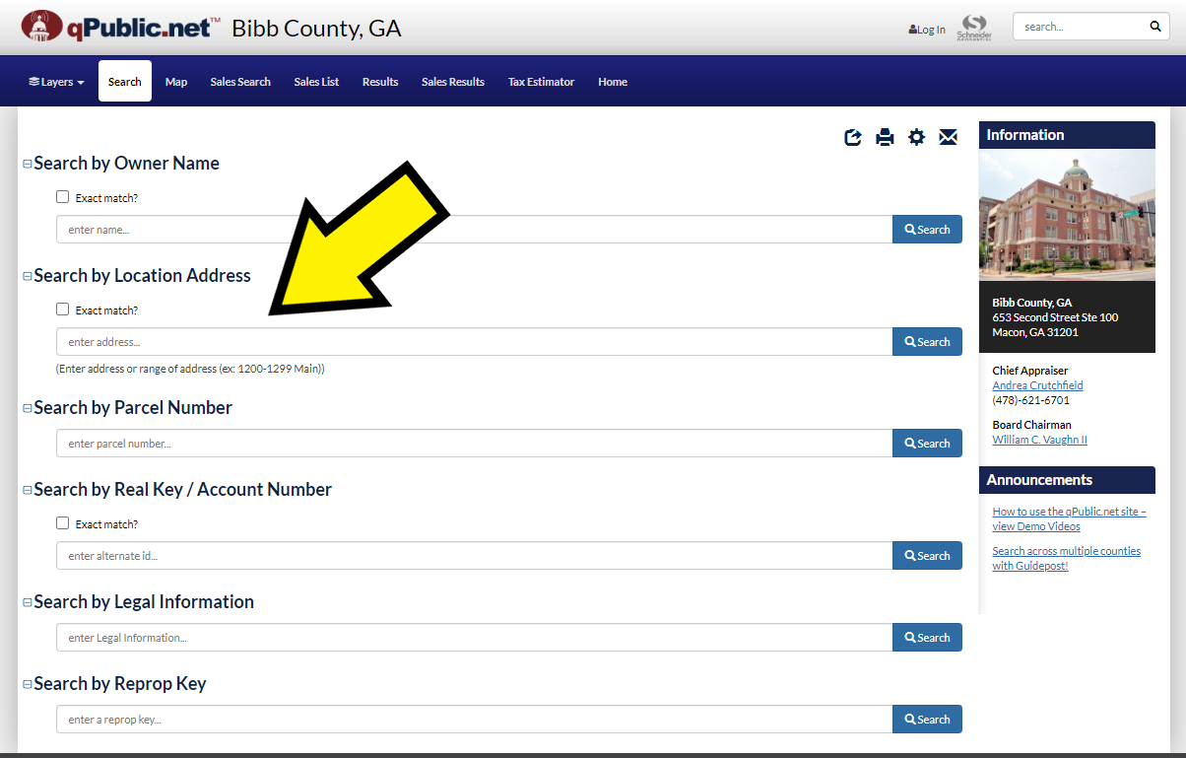
Step 4 You have many options to search, but we recommend by Location Address. It will auto-fill for you if it's already on file.
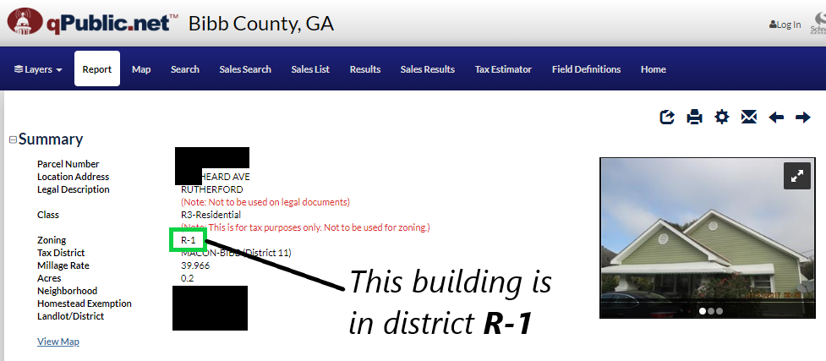
Step 5 Info we are looking for is by 'Zoning'
WHAT DISTRICT (S) ALLOW FAMILY CHILD CARE AND ARE THERE CONDITIONAL REQUIREMENTS?
In Macon-Bibb County each use falls under one of four use cases: Permitted, Conditional, Special Exemption, or Nonconforming Use. The classification of each district’s use type is determined by the Principal Use Table under Section 5.4. Day care homes only fall under Permitted, Conditional, and Nonconforming. A permit of zoning compliance is required in all conforming cases.
If the applicant lives in a district where FCC is a Permitted Use, then a Zoning Permit can be issued by a zoning enforcement officer without a public hearing, (assuming the home meets the conditions in section 23.30 listed previously).
In the applicant lives in a district where FCC is classified as a Conditional Use, there is a separate set of conditional requirements found in Section 3.03 that must be met in order to comply with the zoning law. On top of this, a public hearing would have to be scheduled and advertised to give the community a chance to express any concerns about the use.
In the applicant lives in a district where FCC is a Nonconforming Use, then the use may not take place within that district.
Refer to the table on the following page to determine use type by individual district.

RESIDENTIAL DISTRICTS
Abbrev. | Type | Description | Use Type
RR | Rural Residential |  | Permitted Use
R-1AAAA | Single Family Residential |  | Permitted Use
R-1AAA | Single Family Residential |  | Permitted Use
R-1AA | Single Family Residential |  | Permitted Use
R-1A | Single Family Residential |  | Permitted Use
R1 | Single Family Residential |  | Permitted Use
R-2A | Two Family Residential |  | Permitted Use
R-2 | Two Family Residential |  | Permitted Use
R-3 | Multifamily Residential |  | Permitted Use
C-1 | Neighborhood Commercial |  | Permitted Use
MHR | Manufactured Home Residential |  | Permitted Use
WORK DISTRICTS [Retail / Business / Industrial]
Abbrev. | Type | Description | Use Type
SC | Special Commercial |  | Permitted Use
A | Agricultural |  | Permitted Use
CBD-1 | Central Business |  | Permitted Use
CBD-2 | Central Business |  | Permitted Use
C-2 | General Commercial |  | Permitted Use
C-4 | Highway Commercial |  | Permitted Use
C-5 | Neighborhood Convenience |  | Nonconforming Use
M-1 | Wholesale and Light Industrial |  | Conditional Use
M-2 | Heavy Industrial |  | Nonconforming Use
M-3 | Heavy Industrial |  | Nonconforming Use
OTHER DISTRICTS [Development / Conservation]
Abbrev. | Type | Description | Use Type
PDR | Planned Development |  | Conditional Use
PDC | Planned Development |  | Conditional Use
PDI | Planned Development |  | Nonconforming Use
PDE | Planned Development |  | Conditional Use
AH1 | Airport Hazard | Herbert Small Airport Zone | Conditional Use
AH2 | Airport Hazard | Middle Georgia Regional Airport | Nonconforming Use
AH3 | Airport Hazard | Robins Air Force Base Zone | Nonconforming Use
HR-1 | Historic Zoning |  | Permitted Use
HR-2 | Historic Zoning |  | Permitted Use
HR-3 | Historic Zoning |  | Permitted Use
HC | Historic Zoning |  | Permitted Use
HPD | Historic Zoning |  | Permitted Use
RP | River Protection |  | Conditional Use

IF I DO QUALIFY, WHAT DO I NEED TO DO?
If you reside in a district that allows day care homes as a Permitted Use and your home complies with all specifications of Section 23.30, then the next step is to obtain a zoning permit. Such a certificate can be applied for online at https://mbpz.org/apply/. The zoning enforcement officer then has twenty (20) business days to approve or deny the application, and if it is not explicitly approved or denied within that time frame, it is by default an approval.
Information you will Need:
- Address
- Map/Parcel Number
- District Type
- Is this a new construction?
- Interior or Exterior Use?
- Property on public sewer or septic tank?
- Will signage be added?
- Creek/stream/major drainage on property?
- # of Off-Street Parking Spaces
- Identifying info [Name / Phone Number / Email]
- Days of Operation
- Hours of Operation
- # Of Children
- Child Age Range
- Will you have employees?
- Is outside play area fenced?
- Is property a single family detached dwelling?
- Any permanent residents under 17 years of age?
- Is this your primary residence?
DOES IT COST ANYTHING?
The fee to obtain Certification of Compliance for day care homes in an existing structure is $315 plus $100 for Zoning Compliance Verification, for a total of $415. New structures or extraneous additions [such as signage or requests for appeals] will have additional charges. Charges are obtained from the Macon-Bibb Planning and Zoning Commission Fee Tally Sheet, which can be found at https://mbpz.org/wp-content/uploads/2019/02/2019-Fee-Tally-Sheet.pdf.

*Child Care Law Center, 2003, A Child Care Advocacy Guide to Land Use Principles.

